**Plaza Premium Lounge Celebrates its Ninth Consecutive Victory as the   
“World’s Best Independent Airport Lounge”**

**at the Skytrax World Airline Awards**

* Plaza Premium Lounge has consecutively won the title of "World's Best Independent Airport Lounge" from 2016 to 2025
* Plaza Premium Lounge Rome receives its third victory in a row as the “World’s Best Independent Lounge” from 2023 to 2025.
* Five Plaza Premium Lounges have secured top rankings from its lounge locations in Rome, London, Dubai, Helsinki and Hong Kong.

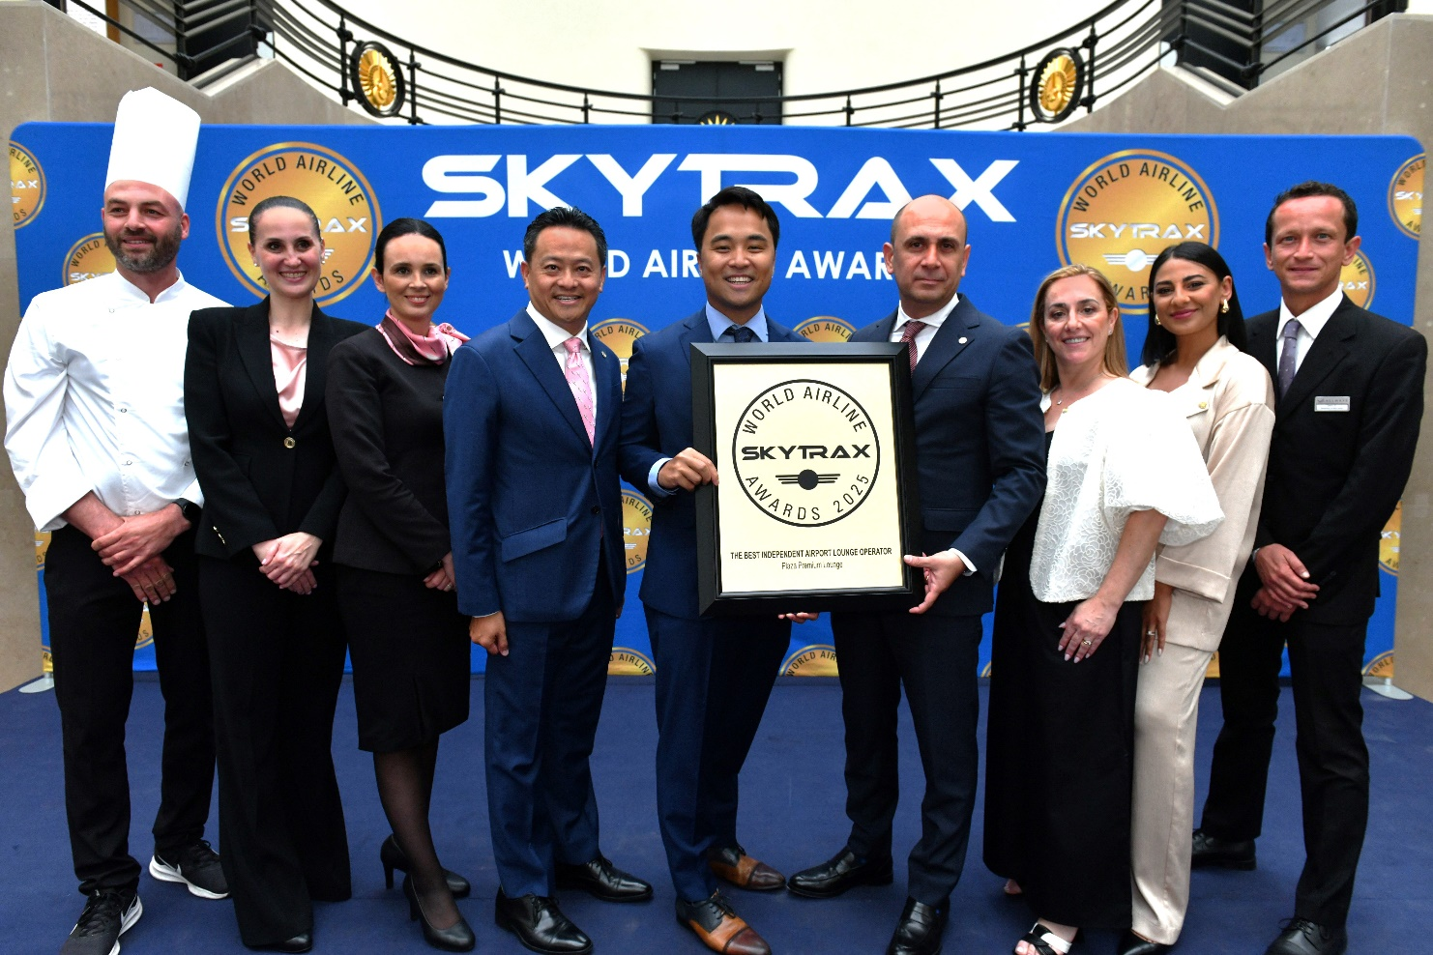  
*Caption: Plaza Premium Group's Leadership Team Jonathan Song, Chief Commercial Officer; Bora Isbulan, Deputy CEO; Analia Marinoff, Area General Manager - Italy, Finland & Germany; and representatives from Plaza Premium Lounge Rome, received the "World's Best Independent Airport Lounge Awards" at The World Airline Awards 2025 in Paris.*

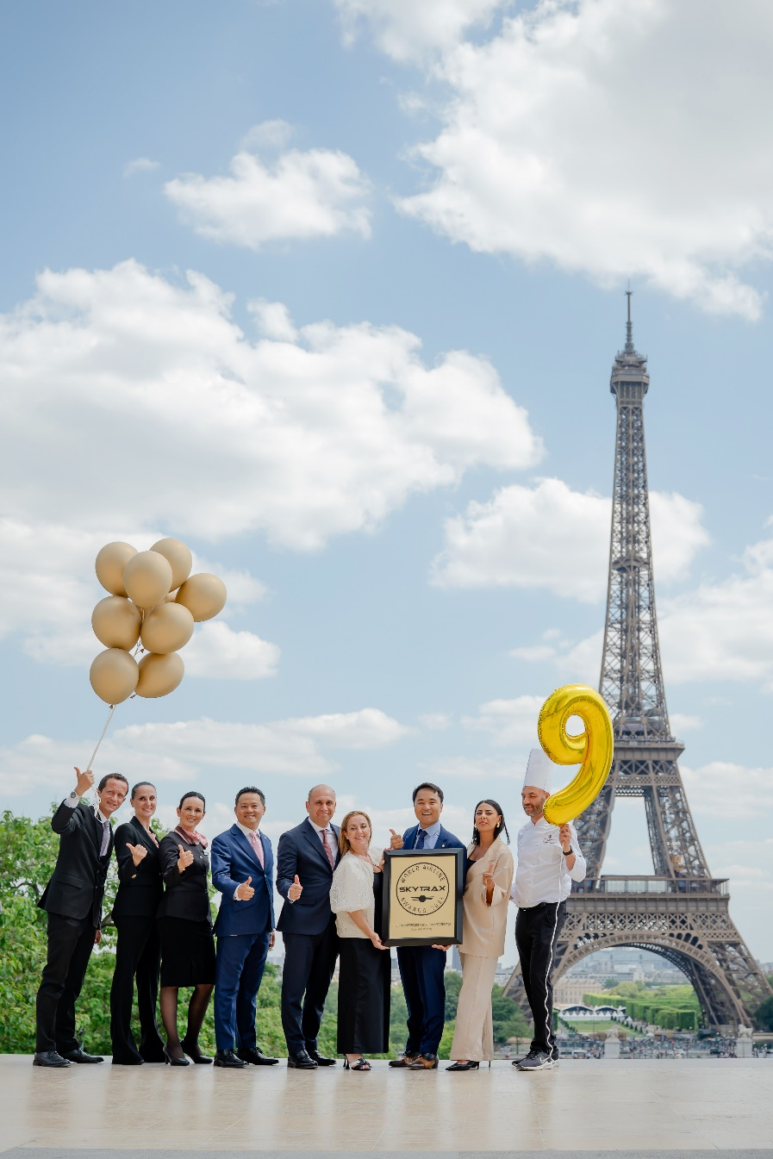

**Hong Kong, 18 June 2025** – Plaza Premium Lounge, the world’s first independent airport lounge brand and the largest global independent lounge network under Plaza Premium Group, today received the "World’s Best Independent Airport Lounge" Award at the prestigious World Airline Awards 2025 by Skytrax, often referred to as the "Oscars of aviation."

This marks the group’s ninth consecutive victory since 2016—a remarkable achievement that underscores its unwavering commitment to excellence. A total of five Plaza Premium Lounges secured top rankings this year.

Plaza Premium Lounge Rome at Leonardo da Vinci-Fiumicino Airport (Terminal 3) has successfully retained its title as the “World’s Best Independent Lounge,” building on its victories in 2023 and 2024. Plaza Premium Lounges at London Heathrow Airport (Terminal 4), Dubai International Airport, Helsinki Airport and Plaza Premium First at Hong Kong International Airport ranked fifth, eighth, thirteenth and nineteenth respectively.

Mr. Song Hoi See, Founder and CEO of Plaza Premium Group said: “Receiving this prestigious award for the ninth consecutive year is an absolute honor. We are deeply grateful to Skytrax, our airport and business partners, and our customers for their ongoing support. I am incredibly proud of our teams; this award is a testament to their hard work, passion, and unwavering commitment to delivering exceptional airport hospitality to travellers every day. Since introducing the world’s first independent airport lounge concept 27 years ago, we have continuously evolved to enhance the airport experience by putting passengers’ needs first. We remain committed to making travel better, focusing on customer experience, sustainability and innovation.”

“We believe lounges are your destination before departure, and it is important to offer experiences that passengers can emotionally resonate with. That’s why we introduced the "Proudly Local" experience last year at Plaza Premium Lounges, now active in 13 locations, including our Top 10 Skytrax-ranked lounges in Rome, London, and Dubai. This initiative connects global travelers with unique stories and offerings from independent artisans and producers, transforming our lounges into cultural gateways that celebrate the places they serve.”

Edward Plaisted, CEO of Skytrax said: "We congratulate Plaza Premium on winning the World's Best Independent Airport Lounge operator award for an incredible ninth consecutive year, which is a truly fabulous achievement. The highest ranked Plaza Premium lounge in 2025 is at Rome Fiumicino Airport, and the Plaza Premium management and staff should be very proud of this very high recognition from customers."

**About the Top Ranked lounges:**

**NO. 1 - Plaza Premium Lounge Rome - Leonardo da Vinci-Fiumicino Airport (T3)**

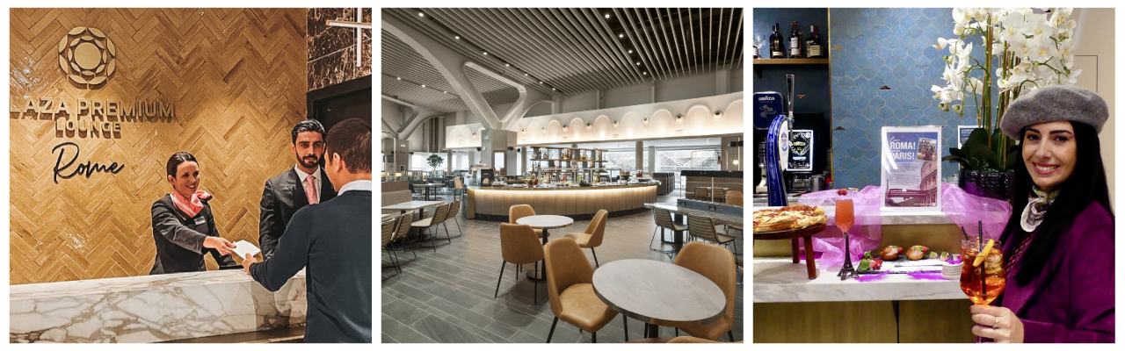

Recognized as the World's Best Independent Airport Lounge from 2023 to 2025, Plaza Premium Lounge Rome offers travellers an immersive experience into the heart of Italy. Experience “la dolce vita” with the eternal city's cultural heritage as you step into the expansive lounge, inspired by ancient Roman architecture.

Explore the curated art, showcasing the cultural significance of this iconic city. The Cultural Lounge Ambassadors epitomise the warm hospitality, ready to treat you to signature dishes and beverages that capture the vibrant flavours of the various regions of Italy.

**NO. 5 - Plaza Premium Lounge London - Heathrow Airport (T4)**

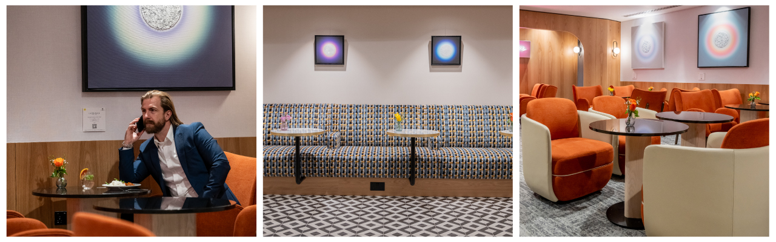

Opened last year, Plaza Premium Lounge at London Heathrow Terminal 4 is the latest addition to our portfolio in London. Travelers can enjoy exceptional hospitality with authentic British classic dishes and drinks in stylish spaces. As part of our global “Art and Lounge” initiative, we also host seasonal exhibitions in collaboration with local British artists to create a gallery-like experience.

**NO. 8 - Plaza Premium Lounge Dubai – Dubai International Airport**

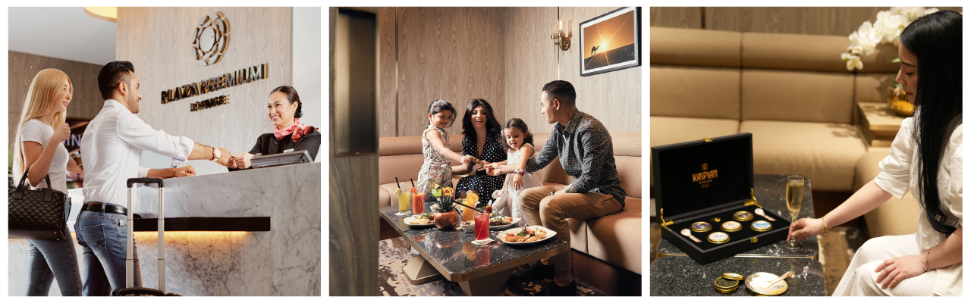

Plaza Premium Lounge Dubai seamlessly blends Emirati culture with global sophistication. Travellers can savour local delicacies, admire art, and experience traditions that reflect the essence of Dubai. For the ultimate indulgence, travellers can enjoy the exclusive Numero Uno Caviar Bar experience. This family-friendly lounge also features a dedicated kids' play area, as well as private family suites complemented by personalized butler service.

**NO. 13 - Plaza Premium Lounge Helsinki – Helsinki Airport (non-Schengen area)**

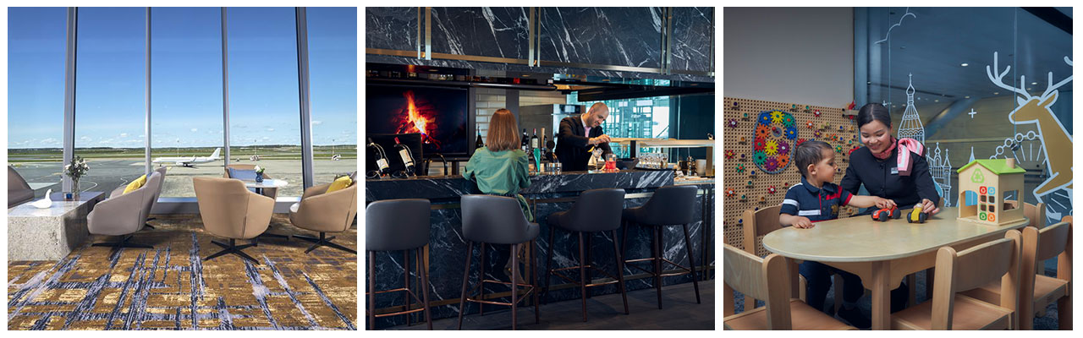

Plaza Premium Lounge Helsinki is one of the most popular spots for family vacationers at Helsinki Airport. The lounge distinguishes itself with the company’s first in-lounge Playroom. This family-friendly space features experiential toys and kids TV channels. It has a dedicated zone with quality wooden toys that are ethically sourced, educational, durable, and safe, created in collaboration with Australian toy brand Masterkidz.

**NO. 19 - Plaza Premium First Hong Kong – Hong Kong International Airport**

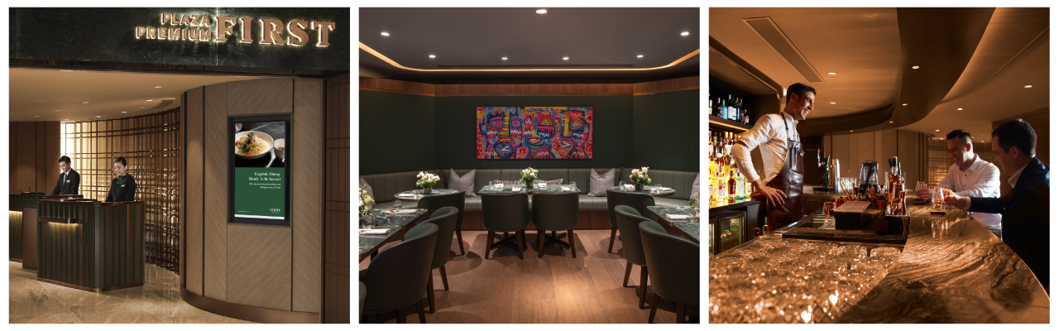

The elevated lounge concept of Plaza Premium First made its global debut in Hong Kong International Airport in 2018, representing a transformative evolution in Plaza Premium Group’s mission to redefine travel and provide sophisticated travellers with the ultimate blend of comfort and personalised service.   
Plaza Premium First Hong Kong aims to elevate the airport journey for discerning travellers with a curated experience that combines luxury and comfort. One of the lounge's standout features is the Infinity Room, a private haven offering à la carte dining crafted by our talented chefs and personalized lounge services. This exclusive space provides extra privacy and personalization, embodying first-class airport hospitality.   
  
Guests can enjoy world-class ala carte dining amidst a stylishly designed contemporary interior, cosy seating, and a curated selection of contemporary artworks that create an intimate and relaxing ambience.

**Download high-res photos here:**

[**https://www.dropbox.com/scl/fo/erz4zo0t4xb4whmv8gyt1/AIyEyffVIVPviRYuzt5FdO8?rlkey=7jfhhjsp4xs9wh2ujytddg72v&st=ys5ggma0&dl=0**](https://www.dropbox.com/scl/fo/erz4zo0t4xb4whmv8gyt1/AIyEyffVIVPviRYuzt5FdO8?rlkey=7jfhhjsp4xs9wh2ujytddg72v&st=ys5ggma0&dl=0)

**PLAZA PREMIUM GROUP**

Plaza Premium Group (PPG) is the global leader in integrated airport hospitality and passenger service solutions, operating the largest network of airport lounges worldwide and offering a 360-degree airport hospitality experience with 14 brands under its portfolio, operating in 150 countries across 600 international and domestic airports and serving 24 million passengers annually.

With a mission to Make Travel Better, the group introduced the world's first independent airport lounge concept in 1998. Plaza Premium Lounge, Plaza Premium First - award-winning airport lounges, Aerotel - the world’s largest airport transit hotel chain, Refreshhh by Aerotel, ALLWAYS - airport passenger services, airport dining concepts, Smart Traveller - innovative digital experience and rewards platform, and One Travel Experience Ecosystem (oneTECO), the group is at the forefront of transforming airport experiences for the better through innovative and human-led solutions. PPG’s commitment extends beyond its brands, as it also provides lounge management and hospitality solutions to leading airlines, alliances, and corporations worldwide. Partnerships include renowned names such as American Express, Capital One, Cathay Pacific Airways, Saudia, SkyTeam, Star Alliance, Visa, and many more. Plaza Premium Group has over 100 accolades, demonstrating its exceptional achievements and commitment to service excellence. Notably, the group has received the prestigious "World's Best Independent Airport Lounge" award at the World Airline Awards by Skytrax for eight consecutive years from 2016 to 2024.  With a team of over 6,000 dedicated professionals worldwide, and through a continuous pursuit of innovation and excellence, the group is experiencing exponential growth globally.

Media Contact:   
Whitney Fung  
Plaza Premium Group PR & Corporate Communications   
[whitney.fung@plaza-network.com](mailto:whitney.fung@plaza-network.com)