FOR IMMEDIATE RELEASE
Plaza Premium Lounge Grand Opening in Taipei Songshan Airport
Taipei’s New Destination for Local Flavours, Artistry, and Elevated Hospitality

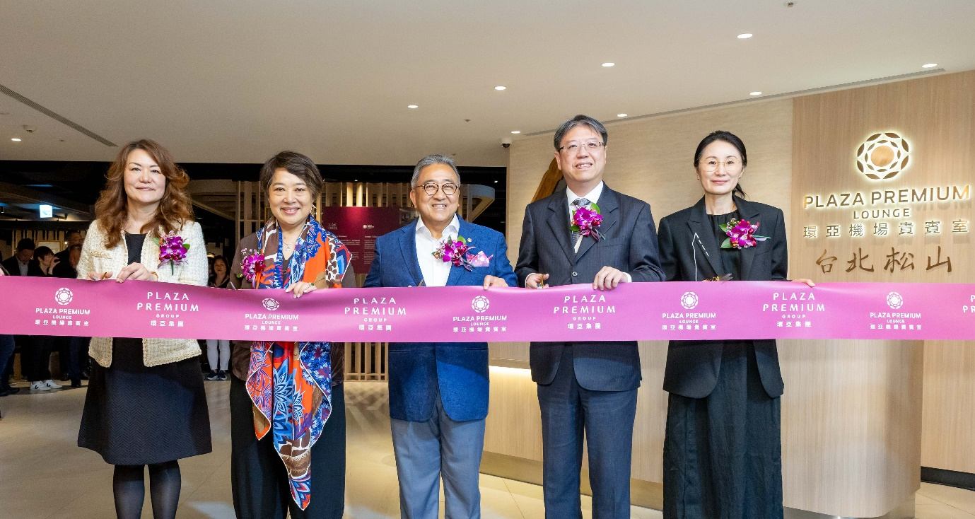
The grand opening was attended by Mr. Song Hoi See, Founder and CEO of Plaza Premium Group (centre). From left to right: Ms. Lulu Lin, General Manager of Taiwan; Ms. Linda Song, Executive Director; Mr. Cheng Chien-Chung, Director of Taipei International Airport, Civil Aviation Administration, MOTC R.O.C.; and Ms. Jenny Zhang, Regional General Manager of North Asia.

[Taipei, Taiwan—12 May 2025] Plaza Premium Group (PPG), the global leader in integrated, 360-degree airport hospitality experiences and passenger service solutions, officially announces the grand opening of its newest lounge at Taipei Songshan Airport, marking the group’s fifth location in Taiwan. This addition is a strategic expansion to the group’s presence in Taiwan, within its global network of 600 international and domestic airports across 150 countries. Located in the heart of Taipei, Songshan Airport stands out as a city airport, similar to London City, Tokyo Haneda, and Shanghai Hongqiao. Its central position makes it especially attractive to business travellers who prioritise swift access to downtown areas and major commercial districts. Songshan’s route network is tailored for regional business travel, offering direct flights to other centrally located airports in key Asian cities, including Tokyo Haneda, Seoul Gimpo, and Shanghai Hongqiao.
Fifth Plaza Premium Lounge in Taiwan
Celebrating Local Roots and International Brand Excellence
Inspired by the richness of Taiwanese culture, the newly opened Plaza Premium Lounge, which sees its role as a platform to showcase local brands and talent, is a dynamic space artfully integrating local cuisine and artistic ambience to offer travellers an extraordinary immersive experience before take-off. Beyond Taiwan’s culinary signatures and art, the lounge also offers a stylish and spacious retreat, ideal for the ultimate in relaxation before every flight. With comfortable seating, complimentary Wi-Fi, and a dedicated VIP area for select credit cardholders and guests seeking greater privacy, the Songshan lounge is designed to balance immersive experiences and cultural warmth, ensuring every journey begins with a sense of hospitality that is uniquely Taiwanese.

Mr. Song Hoi See highlighted Plaza Premium Group’s commitment to the Taiwan market, which began in 2016 when the company opened its first airport lounge. “As a key player in Asian aviation, Taiwan’s strategic location, dynamic tourism sector, and robust business environment create tremendous opportunities for premium travel services. With the opening of our new lounge at Taipei Songshan Airport, we are proud to support the growth of Taiwan’s aviation network and provide travellers with an elevated experience that blends authentic Taiwanese culture, cuisine, and exceptional comfort with personalised services. This milestone reflects our commitment to redefining the airport journey for today’s discerning travellers.”

This latest lounge opening reflects the group’s ongoing strategy to transform the airport experience by blending attentive service with enhanced comfort, setting a new benchmark for airport hospitality in the region.

In his speech, Mr. Cheng Chien-Chung, Director of Taipei International Airport, stated that with the growing number of international travellers following the pandemic, Taipei Songshan Airport has planned to introduce business lounges, allowing passengers to either pay for access or enjoy complimentary entry with designated credit cards. This initiative aims to provide business travellers with customised and diverse options, offering a comfortable and high-quality service environment. The official opening of the Plaza Premium Lounge represents a key milestone in positioning Songshan as the “capital’s business airport” and marks an important step forward in the airport’s ongoing efforts to enhance passenger service quality.

Redefining the Meaning of Travel Luxury
The Debut of “Art of Travel”
To further enhance the brand’s pursuit of excellence, Plaza Premium Group has introduced the Art of Travel series, combining classic art with cutting-edge AI technology. The series includes a collection of films and visual artworks that represent the brand’s five core service pillars: airport lounges, meet-and-greet concierge services, in-terminal transfers, Aerotel airport hotels, and premium limousine services, all of which may soon be available in Taiwan. Through this initiative, travellers can gain deeper insight into Plaza Premium’s commitment to excellence and attention to detail, delivering an elevated and aspirational service experience.

In addition, visitors can enjoy selected works by renowned Taiwanese artist Yi-Hsuan Wu within the lounge. These award-winning pieces not only showcase Taiwan’s unique artistic flair but also enrich the lounge’s cultural ambience. For this collaboration, Wu created an exclusive Instagram-worthy art wall inspired by iconic Taiwanese landmarks, inviting travellers to both appreciate local art and capture unforgettable moments.
Within the Plaza Premium Art Space, a special exhibition titled Floral Whispers: Blooming by local artist Yi-Fan Lu showcases a vibrant series of works inspired by the colours and forms of flowers. The collection captures the passion of life in full bloom and the fluidity of human emotion with Samsung’s collaboration with its state-of-the-art digital art display that seamlessly blends technology with art, bringing out every exquisite detail.
Guests can savour speciality coffee brewed with Hiroia’s smart coffee devices, which combine advanced Internet of Things (IoT) technology with traditional pour-over coffee technology. This allows you to enjoy a coffee experience like never before while maintaining superior taste consistency. Travellers are invited to pause and immerse themselves in this celebration of visual beauty and emotional resonance, a true feast for both the eyes and the soul.
Savour Authentic Taiwanese Hospitality
The Hidden Culinary Gems of Songshan
Plaza Premium Lounge at Taipei Songshan Airport takes pride in presenting a rich array of authentic Taiwanese dishes, freshly prepared to deliver a memorable taste journey. Among the highlights is the beef noodles, a fusion delicacy influenced by Chaozhou cuisine, featuring tender beef, chewy noodles, and a flavourful satay sauce. Another must-try is the Braised Pork Belly with Preserved Vegetables on Rice, which combines juicy pork belly, savoury-sweet sauce, and pickled greens for a rich and layered taste experience.
Travellers can also enjoy traditional Taiwanese street snacks like sticky rice sausage with grilled Taiwanese sausage, which delivers a deliciously nostalgic combination, and Bamboo Tube Rice, a tribal speciality steamed in fresh bamboo to infuse the grains with a unique aroma. Vegetarian guests are also well-catered to, with a wide selection of plant-based delights that celebrate the essence of Taiwanese cuisine. The lounge also features Layana Cutlery, Taiwan’s first premium 316 stainless steel chopsticks, for a refined and sustainable dining touch.
In addition to its signature hospitality and local culinary offerings, the Taipei Songshan lounge caters to the unique traveller demographic of Songshan Airport by debuting a first-of-its-kind service in Taiwan: “Lounge To Go.” For travellers short on time, freshly prepared boneless crispy fried chicken cutlet, freshly poured-over coffee by Hiroia, and other gourmet selections can now be conveniently taken to the boarding gate, allowing the indulgent lounge experience to accompany guests to their next destination.
The Plaza Premium Lounge at Taipei Songshan Airport is located on the third floor of the Departures area in Terminal 1. It operates daily from 5:30 AM to 8:30 PM. After check-in and immigration clearance, travellers can access this tranquil oasis via payment or eligible credit cards.
Download high-resolution photos here.

About Plaza Premium Group
Plaza Premium Group (PPG) is the global leader in integrated airport hospitality and passenger service solutions, operating the largest network of airport lounges worldwide and offering a 360-degree airport hospitality experience with 14 brands under its portfolio, operating in 150 countries across 600 international and domestic airports and serving 24 million passengers annually. With a mission to Make Travel Better, the group introduced the world's first independent airport lounge concept in 1998.
Plaza Premium Lounge, Plaza Premium First - award-winning airport lounges, Aerotel - the world’s largest airport transit hotel chain, Refreshhh by Aerotel, ALLWAYS - airport passenger services, airport dining concepts, Smart Traveller - innovative digital experience and rewards platform, and One Travel Experience Ecosystem (oneTECO), the group is at the forefront of transforming airport experiences for the better through innovative and human-led solutions. PPG’s commitment extends beyond its brands, as it also provides lounge management and hospitality solutions to leading airlines, alliances, and corporations worldwide. Partnerships include renowned names such as American Express, Capital One, Cathay Pacific Airways, Saudia, SkyTeam, Star Alliance, Visa, and many more.
Plaza Premium Group has over 100 accolades, demonstrating its exceptional achievements and commitment to service excellence. Notably, the group has received the prestigious "World's Best Independent Airport Lounge" award at the World Airline Awards by Skytrax for eight consecutive years from 2016 to 2024.
With a team of over 6,000 dedicated professionals worldwide, and through a continuous pursuit of innovation and excellence, the group is experiencing exponential growth globally.
To learn more: https://www.plazapremiumgroup.com
Connect with us: LinkedIn, YouTube: @Plaza Premium Group; Facebook, Instagram: @plazapremiumlounge; X: @We_Are_PPG; WeChat, Weibo: @環亞全球出行PlazaPremiumGroup; Instagram (mysmarttraveller): @mysmarttraveller

Media Contacts:
Beatrice Chen
Plaza Premium Group
Marketing Manager – Taiwan
Tel: ＋886 910 926 468
Email: beatrice.chen@plaza-network.com

Virginia Luk
Plaza Premium Group
PR & Corporate Communications - Global
Email: virginia.luk@plaza-network.com

