FOR IMMEDIATE RELEASE

Plaza Premium Group’s Smart Traveller Named the “Flyer’s Preferred Innovative Loyalty Program of the Year” at the 13th Flyer's Preferred Award Ceremony 2025

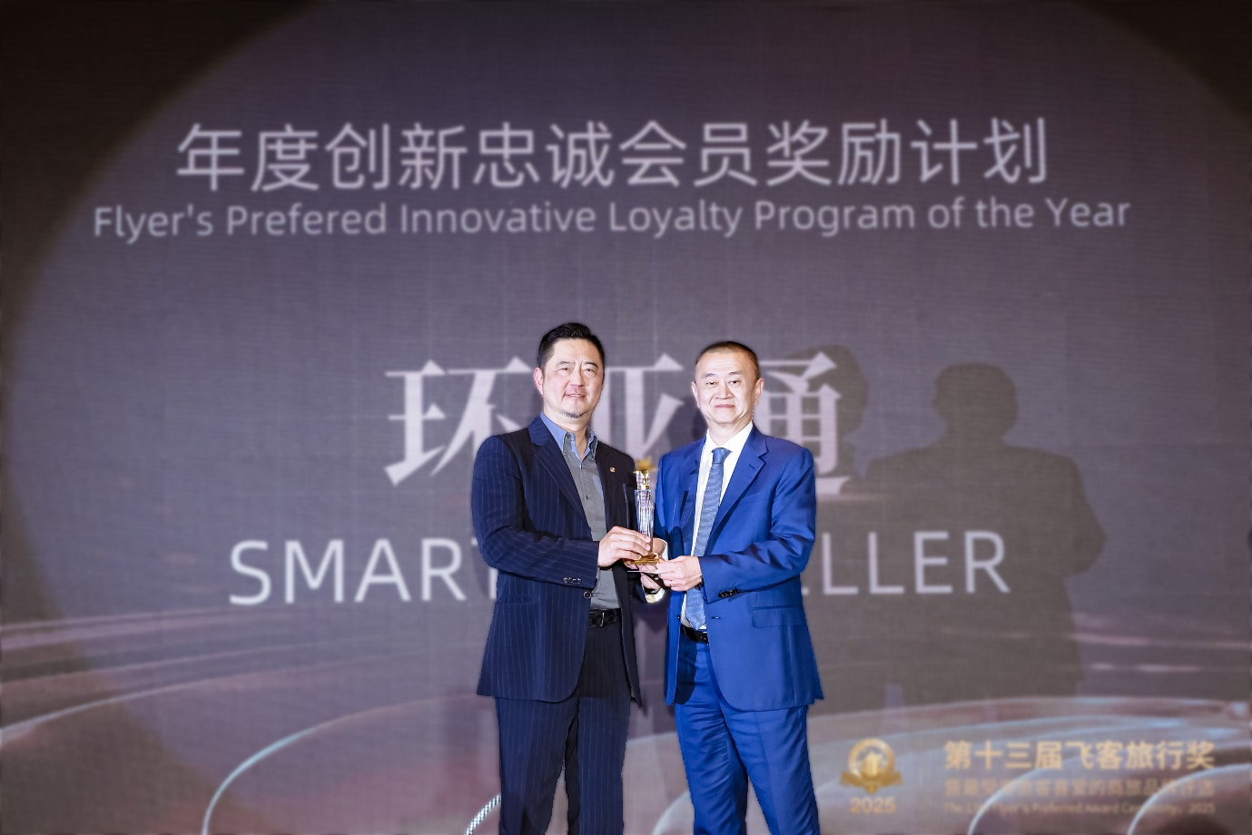
Plaza Premium Group’s Managing Director of Smart Traveller, Simon Huang (left) receiving the Flyer’s Preferred Innovative Loyalty Program of the Year award from Visa’s Global Vice President and President of China, Yin Xiaolong (right)

Hong Kong, 25 April 2025 - Plaza Premium Group (PPG)’s Smart Traveller, PPG’s innovative digital experience and rewards platform, was named the “Flyer’s Preferred Innovative Loyalty Program of the Year” at the 13th Flyer’s Preferred Award Ceremony 2025, co-organised by CAAC Inflight Magazine, the official inflight publication of the Civil Aviation Administration of China (CAAC), and FlyerT, China’s leading social networking platform for frequent flyers. The prestigious award ceremony brought together senior leaders from domestic and international airlines, major hotel groups, bank credit card centers, and the business travel service sector, alongside numerous media representatives and industry elites.
The 13th Flyer’s Preferred Awards Ceremony is widely recognized for its credibility and impartiality in honouring excellence within the business travel sector. Its reputation is built on a rigorous dual-core evaluation system that integrates verified user data with authentic experiences from frequent travellers, ensuring that the results accurately reflect industry standards and traveller satisfaction. This comprehensive and objective assessment spanned multiple vertical industries within the business travel sector, culminating in nearly thirty awards across airlines, hotels, credit cards, and cruises.
At the award ceremony, Simon Huang, Plaza Premium Group’s Managing Director of Smart Traveller, collected the “Flyer’s Preferred Innovative Loyalty Program of the Year” award on behalf of PPG. This accolade not only underscores PPG’s commitment to innovation in creating the ultimate digital experience and rewards platform but also demonstrates its unwavering dedication to making travel better through cutting-edge solutions and customer centric innovations.
“It is truly a proud moment for Smart Traveller to receive this prestigious industry accolade in Mainland China for the first time. We are deeply grateful to FlyerT, our partners, members, seasoned travellers and business professionals for their continued support. We will continue to elevate our offerings and raise the bar in business travel with seamless, personalised and digitalised solutions that enhance the travel experience for all our members.” said Simon Huang, Managing Director, Smart Traveller.
The 13th Flyer’s Preferred Awards Ceremony not only provided a distinguished platform for showcasing leading business travel brands and celebrated their outstanding achievements, but also enhanced collaboration and knowledge exchange within the industry. Plaza Premium Group is proud to be part of this dynamic ecosystem, collaborating with partners and travellers to elevate the business travel industry. As the industry continues to evolve, PPG looks forward to contributing to its growth and innovation, making travel better for all.

Download high-resolution photos here.

About Plaza Premium Group
Plaza Premium Group (PPG) is the global leader in integrated airport hospitality and passenger service solutions, operating the largest network of airport lounges worldwide and offering a 360-degree airport hospitality experience with 14 brands under its portfolio, operating in 150 countries across 600 international and domestic airports and serving 24 million passengers annually. With a mission to Make Travel Better, the group introduced the world's first independent airport lounge concept in 1998.
Plaza Premium Lounge, Plaza Premium First - award-winning airport lounges, Aerotel - the world’s largest airport transit hotel chain, Refreshhh by Aerotel, ALLWAYS - airport passenger services, airport dining concepts, Smart Traveller - innovative digital experience and rewards platform, and One Travel Experience Ecosystem (oneTECO), the group is at the forefront of transforming airport experiences for the better through innovative and human-led solutions. PPG’s commitment extends beyond its brands, as it also provides lounge management and hospitality solutions to leading airlines, alliances, and corporates worldwide. Partnerships include renowned names such as American Express, Capital One, Cathay Pacific Airways, SkyTeam, Star Alliance, Visa, and many more.
Smart Traveller is Plaza Premium Group's global digital rewards program designed to enhance airport experiences for travellers. It offers exclusive rewards and tailored benefits for every journey, whether departing, in transit, or arriving. The Smart Traveller app includes features such as Link My Card for easy lounge access, Flight Information Displays (FIDs) for real-time flight updates, and Smart Order for convenient food and beverage service. With Smart Traveller, travellers can access over 100 Plaza Premium Lounge and Plaza Premium First locations worldwide, offering relaxation before flights. Rewards can be earned not only through lounge visits but also from dining at selected outlets and hotel stays, allowing travellers to accumulate points redeemable for various airport services and travel experiences.
Plaza Premium Group has over 100 accolades, demonstrating its exceptional achievements and commitment to service excellence. Notably, the group has received the prestigious "World's Best Independent Airport Lounge" award at the World Airline Awards by Skytrax for eight consecutive years from 2016 to 2024.
With a team of over 6,000 dedicated talents worldwide, and through a continuous pursuit of innovation and excellence, the group is experiencing exponential growth globally.

To learn more: https://www.plazapremiumgroup.com

Connect with us:
LinkedIn, YouTube: @Plaza Premium Group; Facebook, Instagram: @plazapremiumlounge; X: @We_Are_PPG; WeChat, Weibo: @環亞全球出行PlazaPremiumGroup; Instagram (mysmarttraveller): @mysmarttraveller

Media Contact:
Ada Jin, Marketing Department – China, Plaza Premium Group
ada.jin@plaza-network.com
Virginia Luk, PR & Corporate Communications – Global, Plaza Premium Group
virginia.luk@plaza-network.com

