Plaza Premium Group Expands in Macau with New Plaza Premium First

- The strategic expansion is part of the group’s commitment to Greater Bay Area
- Plaza Premium First aims to cater to market needs for elevated lounge services
- The launch marks the group’s 10th Anniversary since its debut in Macau market

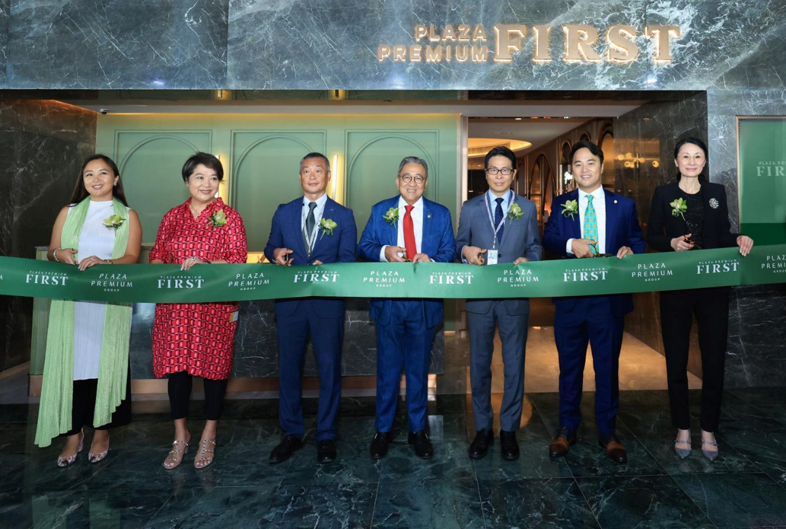

Caption: Plaza Premium First Macau was officially inaugurated today by the Plaza Premium Group leadership team, witnessed by representatives from Macau International Airport Company Limited and Macao Government Tourism Office.
(From left to right: Ms. Mei Mei Song, Chief Transformation Officer of Plaza Premium Group; Mrs. Linda Song, Executive Director of Plaza Premium Group; Mr. Chan Weng Hong, Chairman of the Executive Committee of Macau International Airport Company Limited ; Mr. Song Hoi-See, Founder and Chief Executive Officer of Plaza Premium Group; Mr. Cheng Wai Tong, Acting Director of Macao Government Tourism Office ; Mr. Jonathan Song, Chief Commercial Officer of Plaza Premium Group; Ms. Jenny Zhang, Regional General Manager - North Asia of Plaza Premium Group)

[Macau, China, September 30, 2024] – Plaza Premium Group (PPG), the leading global airport hospitality services provider, opens its highly anticipated Plaza Premium First lounge at Macau International Airport. This addition is a strategic expansion to the group’s presence in Macau within its global network of over 75 international airports in 30 countries & regions. This year also marks the group’s 10th Anniversary in Macau since the inception of Plaza Premium Lounge in Macau International Airport.
Plaza Premium First Macau is located conveniently near Departure Gate 10/10A of Macau International Airport and spans 5,000 square feet. This is the fourth lounge in this exclusive collection of luxurious airport havens featuring all-inclusive personalised hospitality services which has opened in the cosmopolitan capitals of Hong Kong, Kuala Lumpur and Jakarta. The new elevated lounge concept represents a transformative evolution in Plaza Premium group’s mission to make travel better and provide sophisticated travellers with the ultimate blend of comfort and personalised hospitality.
“Ten years ago, we opened our first lounge at Macau International Airport. Over the past decade, we have witnessed the growth and evolution of the tourism industry in the city. Today, we are excited to expand in Macau with our new Plaza Premium First. Through the new lounge, we aim to enhance the journeys for travellers who value curated experiences. With the airport expansion plan and the opportunities presented by the Greater Bay Area and China, we believe this is a favourable time for PPG to expand in Macau.” said Mr. Song Hoi-See, Founder and CEO of PPG.

The Plaza Premium First lounge concept transforms and elevates the travel experience with personalized hospitality, made-to-order signature dishes and a cross-brand journey for elite travellers. Iconic Macanese delicacies such as the famed Macanese style Portugese Chicken, Portuguese egg tart and the classic Pork Chop Bun, symbolises the “Proudly Local” theme that the Plaza Premium Group has introduced at selected lounges globally to showcase diverse cultures through art, food and local traditions.

“As of August 2024, Macau International Airport (MIA) has welcomed 5.2 million passengers, steadily recovering to 80% of its 2019 levels. Renowned for exemplary customer service, MIA provides 24/7 specialized staff and efficient check-in processes. We prioritize safety and hygiene while offering diverse transportation options, multilingual support for passengers, and sustainability initiatives that enhance the travel experience. Additionally, MIA has successfully attained the Airport Customer Experience Accreditation (ACE) from Airport Council International (ACI) for three consecutive years since 2021, underscoring our commitment to improving customer experience. MIA aims to deliver the best airport experience together with our airport partners, including PPG, for this great mission,” said Mr. Chan Weng Hong, Chairman of the Executive Committee, Macau International Airport Company Limited (CAM).
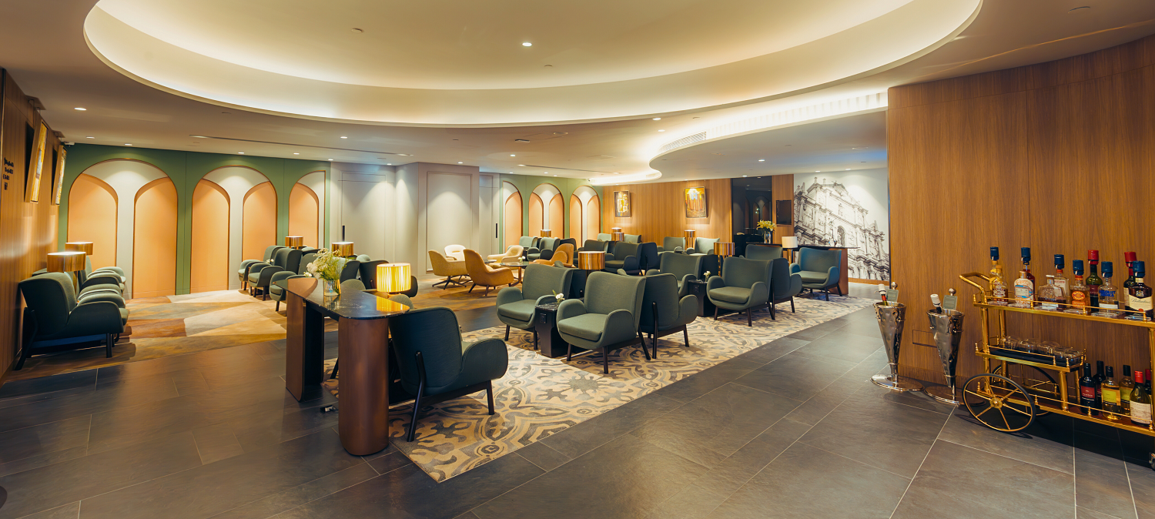
Plaza Premium First Lounge Bay

Acting Director of Macao Government Tourism Office, Cheng Wai Tong expressed, “It is to our great delight that Plaza Premium Group inaugurates its fourth Plaza Premium First in the world at Macau International Airport. It speaks to the positive outlook that Plaza Premium Group embraces about the future of tourism in Macao. Plaza Premium First serves delicacies in Macao’s signature style, which is set to elevate travelers’ overall experience. Their remarkable services will support Macao’s tourism industry as it progresses towards greater diversity and sustainability.”

With a solid presence in the Greater Bay Area market, the opening of Plaza Premium First in Macau is a key component of the company’s Greater China business transformation strategy, as well as the Group’s expansion plan in North Asia. This project aligns well with Macau Airport’s expansion strategy, which aims to increase its annual passenger capacity to 13 million by 2029, and contributes to the tourism development of the Greater Bay Area. According to the International Air Transport Association (IATA), the Greater Bay Area, comprising Macau, is projected to see 387 million passenger trips by 2030." ¹

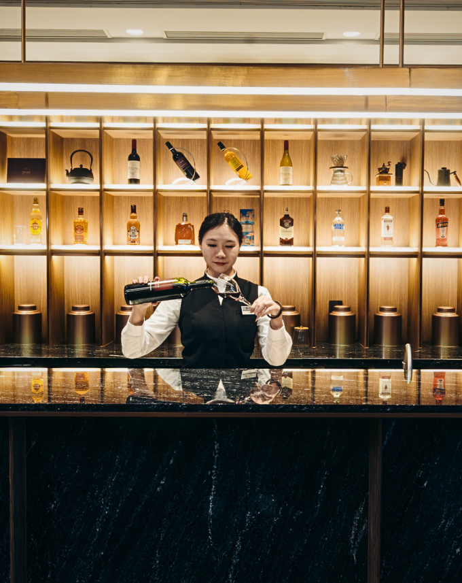 | 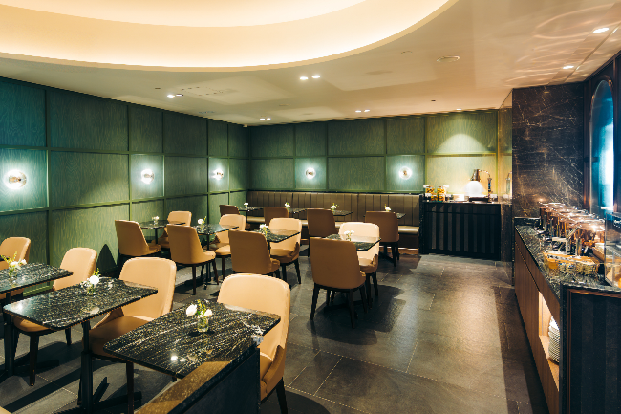
Plaza Premium First Bar | Plaza Premium First Dinning Zone

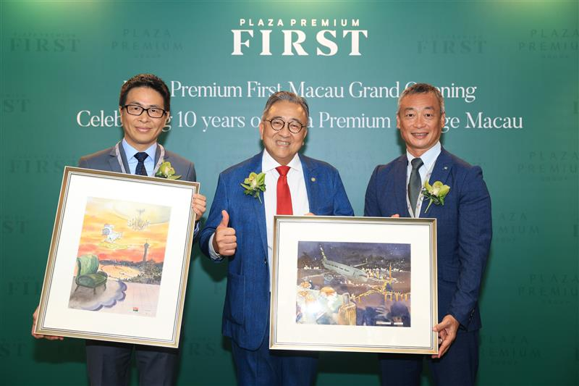
Mr. Song Hoi-See, Founder and CEO of Plaza Premium Group presented a unique set of original watercolour art depicting the destination highlights of Macau to Mr. Chan Weng Hong, Chairman of the Executive Committee of Macau International Airport Company Limited and Mr. Cheng Wai Tong, Acting Director of Macao Government Tourism Office.The artwork was created by Ada Zhang, a famous young local artist from Macau who is the Director of Macau Contemporary Watercolour Artists Association.
(Left to right: Mr. Cheng Wai Tong ; Mr. Song Hoi-See ; Mr. Chan Weng Hong)
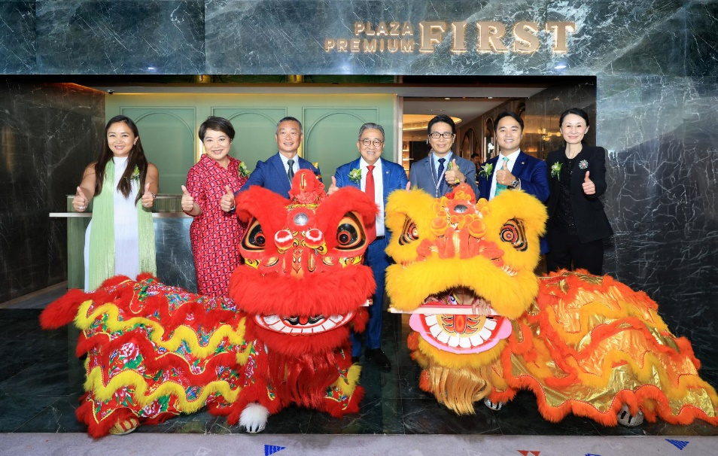

Reference:
1 - Macau International Airport expansion to kick off in 2024 (macaonews.org)

-End-

For more details and booking, please visit:
https://www.plazapremiumlounge.com/en-uk/find/china-regions/macau/macau/macau-international-airport/plaza-premium-first
Download high-res images here:
Dropbox here
Media Contact:
Victor Lam – Macau Marketing, Plaza Premium Group
victor.lam@plaza-network.com
Whitney Fung, PR & Corporate Communications - Global, Plaza Premium Group
whitney.fung@plaza-network.com

About Plaza Premium Group

Plaza Premium Group, headquartered in Hong Kong and established in 1998, is a pioneering global airport hospitality services provider. With a mission to Make Travel Better, the group introduced the world's first independent airport lounge concept.
Today, PPG operates the largest network of international airport lounges worldwide and offers a 360-degree airport experience with 13 brands under its portfolio, spanning over 1600 touchpoints across more than 75 international airports and 30 countries & regions worldwide.
From airport lounge brands - Plaza Premium Lounge & Plaza Premium First, to terminal hotels - Aerotel & Refreshhh by Aerotel, to concierge services - ALLWAYS, a range of airport dining concepts, global reward and membership program - Smart Traveller, and travel experience ECOsystem - oneTECO, the group is at the forefront of transforming airport experience for the better through innovative and human-led solutions. PPG’s commitment extends beyond its own brands, as it also provides lounge management and hospitality solutions to leading airlines, alliances, and corporates worldwide. Partnerships include renowned names such as American Express, Capital One, Cathay Pacific Airways, SkyTeam, Star Alliance, Visa, and many more.
Plaza Premium Group has over 80 accolades demonstrating its exceptional achievements and commitment to service excellence. Notably, the group has received the prestigious "World's Best Independent Airport Lounge" award at the World Airline Awards by Skytrax for eight consecutive years from 2016 to 2024. TTG Asia also recognized the group as the "Best Airport Lounge Operator" in 2018, 2019 and 2023. In 2020, it achieved the "ISO 9001:2015" certification for its Hong Kong Headquarters. Furthermore, the group's Founder and CEO, Mr. Song Hoi-see, was awarded the “Ernst & Young Entrepreneur of the Year” and “Master Entrepreneur of the Year Malaysia” in 2018.
With a team of over 5,000 dedicated talents, PPG serves more than 20 million global passengers annually. Through a continuous pursuit of innovation and excellence, the group is experiencing exponential growth globally.

To learn more: https://www.plazapremiumgroup.com/
Connect with us: FB, IG, @plazapremiumlounge and WeChat @PlazaPremiumGroup

