**Plaza Premium Group prepares for future-focused growth, announcing US$300m investment for the next three years**

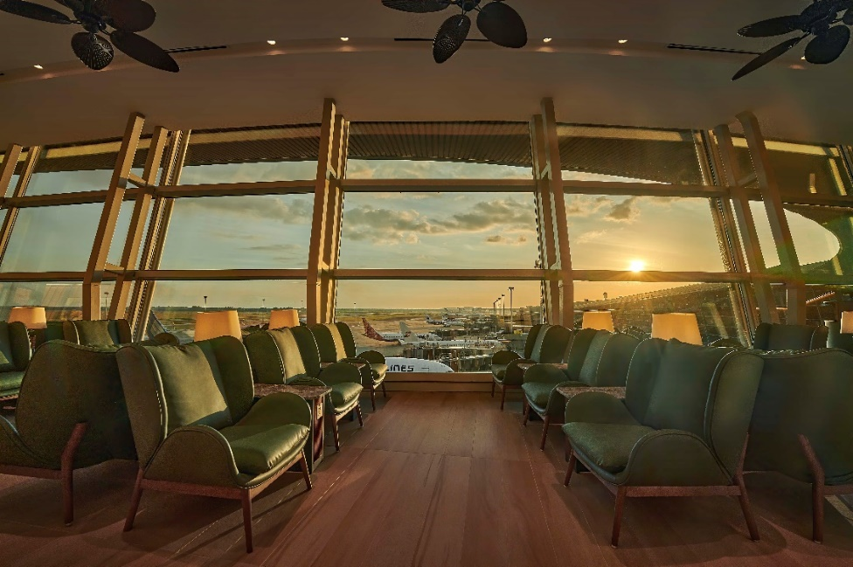

*[Hong Kong, 25 June 2024]* – Plaza Premium Group (PPG), the leading global airport hospitality services provider who has just received its 8th “World’s Best Independent Airport Lounge” titles by Skytrax, is poised for a new era of innovation and growth following the announcement of a US$300m global investment into the next three years. With a global footprint of 250 locations in over 80 airports and 30 countries worldwide, the Hong Kong-based company continues to build on its legacy of excellence. It is committed to driving sustainable solutions, cutting-edge technologies, and enhanced customer experience to make travel and the airport experience better.

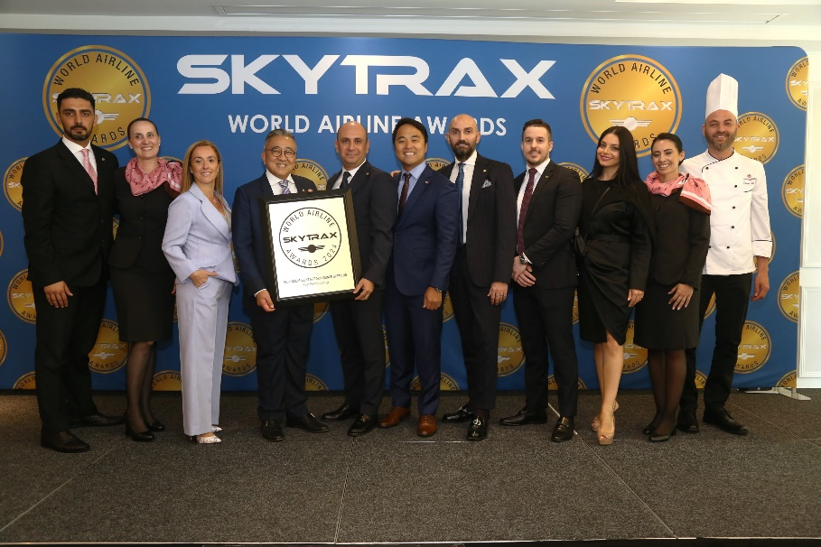

**Investment in Growth**

PPG has committed a substantial investment of US$300 million to fuel its growth initiatives over the next three years. This investment will focus on several key areas, including:

* **Strategic Market Expansion:** Strengthening PPG’s presence in strategically chosen international markets, specifically the world's top 100 busiest airports, and becoming their airport hospitality partner of choice. A significant US$160m will be invested in growth in APAC, with a focus on Southeast Asia and India. Another US$100m is being spent on developing operations in the Middle East, a key region of growth, with a new office opening in Riyadh led by its deputy CEO, Bora Isbulan. Other strategic markets where investment will be spent include the UK and the Americas.
* **Product diversification:**  PPG introduces OneTECO (TravelExperienceEcosystem), a management system that seamlessly connects the demand and supply sides of the entire airport hospitality ecosystem under one platform. Serving as a centralized marketplace, it brings together various airport services including lounges, hotels, and over 17 airport passenger services*. This first-of-its-kind digital product aims to bridge the fragmented market and enhance operational efficiency for airport services.
* **Research & Development:** The company is increasing its investment in research and development to advance services and customer experience using technology, digitalization, as well as robotics, including the opening of an innovation hub to pilot new technologies in Hong Kong. Under the leadership of Chief Technology Officer, Prasan Verma, PPG is working on developing robotic assistance in lounges and AI technology to streamline and facilitate services across Whatsapp, the website and customer sentiment analysis. The company is also working on building its own dynamic pricing based on heatmapping, to move to a demand-based pricing model.
* **Enhancing Sustainable Practices:** PPG has recently appointed a Global ESG lead, Dr. Syafrina Sharif, and commissioned a materiality study to develop a sustainability strategy - the first in a series of steps being taken to accelerate efforts to reduce the environmental impact of the business.
* **Fostering talent development:** PPG is a company that represents a diverse workforce with over 5,000 employees from more than 80 nationalities, and it will continue cultivating a dynamic and inclusive workplace that attracts and retains top talent. The appointment of a new Chief Human Resources Officer, Roy Pang, was recently announced to champion growth that aligns with these core principles.

**Post-covid Surge in Demand**

PPG has seen significant growth across all aspects of the business in the last five years. Since 2019, more than 70 new locations have been opened across 35 new airports. The organic growth across the portfolio - including airport lounges, dining outlets, transit hotels and airport passenger services – has increased by 35.3%. The organisation now has more than 250 locations in over 80 airports across 30 countries with a strong pipeline of new openings scheduled for 2024.

**Future-focused Growth**

Having witnessed the company’s growth from the ground up to meet the needs of an ever-evolving industry, Plaza Premium Group’s founder, Mr. Song Hoi-see, says “Our industry is developing rapidly, and it’s crucial that we stay ahead of the curve. I’m honoured to lead Plaza Premium Group into this exciting new chapter, focusing on the core pillars of sustainability, people and innovation.”

Jonathan Song, Global Director of Business Development added, “Our investment in global expansion and innovation will support our aspiration to become a household name in airport hospitality. We believe it will also propel the growth of the entire airport business ecosystem. By working closely with the world's leading airports, we aim to strengthen global connectivity and deliver exceptional experiences to make travel better for travelers."

Plaza Premium Group is excited to announce several new projects opening in 2024, further cementing its commitment to global growth. Imminent new openings in key destinations, including Abu Dhabi, London, Vancouver, Kenya, Kuala Lumpur, Indonesia, Chongqing, Osaka. In addition to the above, PPG will be launching a travel solution program, Smart Traveller, in Q3 of 2024.

* Ends –

**NOTES TO EDITORS**

**For more information, please contact Companion Communications:**

Dominique Backhouse: [dominique@companioncommunications.com](mailto:dominique@companioncommunications.com)

Caroline Pitt: [caroline@companioncommunications.com](mailto:caroline@companioncommunications.com)

**Plaza Premium Group PR & Corporate Communications**  
Whitney Fung: [whitney.fung@plaza-network.com](mailto:whitney.fung@plaza-network.com)

**About Plaza Premium Group**

Plaza Premium Group, headquartered in Hong Kong and established in 1998, is a pioneering global airport hospitality services provider. With a mission to Make Travel Better, the group introduced the world's first independent airport lounge concept.

Today, PPG operates the largest network of international airport lounges worldwide and offers a 360-degree airport experience with 13 brands under its portfolio, spanning over 1600 touchpoints across more than 80 international airports and 30 countries & regions worldwide.

From airport lounge brands - Plaza Premium Lounge & Plaza Premium First, to terminal hotels - Aerotel & Refreshhh by Aerotel, to concierge services - ALLWAYS, a range of airport dining concepts, global reward and membership program - Smart Traveller, and travel experience ECOsystem - oneTECO, the group is at the forefront of transforming airport experience for the better through innovative and human-led solutions. PPG’s commitment extends beyond its own brands, as it also provides lounge management and hospitality solutions to leading airlines, alliances, and corporates worldwide. Partnerships include renowned names such as American Express, Capital One, Cathay Pacific Airways, SkyTeam, Star Alliance, Visa, and many more.

Plaza Premium Group has over 80 accolades demonstrating its exceptional achievements and commitment to service excellence. Notably, the group has received the prestigious "World's Best Independent Airport Lounge" award at the World Airline Awards by Skytrax for eighth consecutive years from 2016 to 2024. TTG Asia also recognized the group as the "Best Airport Lounge Operator" in 2018, 2019 and 2023. In 2020, it achieved the "ISO 9001:2015" certification for its Hong Kong Headquarters. Furthermore, the group's Founder and CEO, Mr. Song Hoi-see, was awarded the “Ernst & Young Entrepreneur of the Year” and “Master Entrepreneur of the Year Malaysia” in 2018.

With a team of over 5,000 dedicated talents, PPG serves more than 20 million global passengers annually. Through a continuous pursuit of innovation and excellence, the group is experiencing exponential growth globally.

To learn more: [https://www.plazapremiumgroup.com/](https://apc01.safelinks.protection.outlook.com/?url=https%3A%2F%2Fwww.plazapremiumgroup.com%2F&data=05%7C02%7Cwhitney.fung%40plaza-network.com%7Cb73228f69649471153ed08dc8c4b2e82%7C57c780997a6f42de9103b6ff47502aac%7C0%7C0%7C638539501783740352%7CUnknown%7CTWFpbGZsb3d8eyJWIjoiMC4wLjAwMDAiLCJQIjoiV2luMzIiLCJBTiI6Ik1haWwiLCJXVCI6Mn0%3D%7C0%7C%7C%7C&sdata=e1yaoen78nb4kWIILR4XwqpHpbtRvi5CKGWQ1hcLd0A%3D&reserved=0)

 Connect with us: FB, IG, @plazapremiumlounge and WeChat @PlazaPremiumGroup