Plaza Premium Lounge at Heathrow and Gatwick Airport
Unveil New Exhibitions of Contemporary British Art

- Marcia Scott Flow exhibition displayed at Heathrow Airport, Terminal 2 Departures
- Joe Machine Nature exhibition displayed at Gatwick Airport, North Terminal

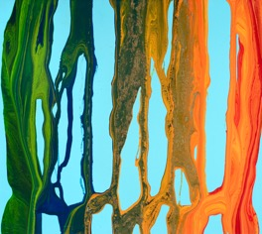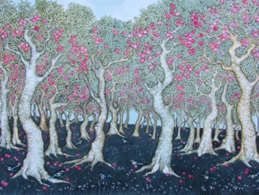

Left: Marcia Scott, Canter, on view at Plaza Premium Lounge Heathrow Terminal 2
Right: Joe Machine, Wealden Orchard with Magpies, on view at Plaza Premium Lounge Gatwick North Terminal.

LONDON, April 2024 - Plaza Premium Lounge is presenting two new concurrent Spotlight Art exhibitions, Marcia Scott Flow at London Heathrow Terminal 2 and Joe Machine Nature at Gatwick North Terminal.

This is the fourth instalment of new artists following the success of the ‘Art and Lounge’ concept series previously introduced in Dubai, Kuala Lumpur as well as London, in collaboration with curators Amie Conway and Alex Cousens, aiming to create an immersive gallery ambiance within the airport. Additional exhibitions featuring contemporary art are in the planning stages and will be announced soon across Plaza Premium Group's departure locations throughout Europe.

Plaza Premium Lounge is dedicated to enhancing the travel experience by showcasing the work of local British artists. Integrating their artworks into the lounge environment not only adds a unique cultural dimension to the travel experience but also offers travellers a glimpse into the artistic landscape of the lounge as a destination before departure.

Travellers can also expect an engaging experience with the artists. Plaza Premium Lounge London Heathrow Terminal 2 and Gatwick North Terminal will both host ‘Meet the Artist’ sessions in May. Marcia Scott will share how she brings "Flow" collection to life at Heathrow, while travellers can witness Joe Machine create his captivating nature-inspired pieces in real-time at Gatwick. These sessions offer a unique opportunity to see the artistic vision unfold and engage with the artists themselves. The ‘Art and Lounge’ concept contributes to making travel better by enriching the overall journey and creating a relaxing environment that engages and inspires travellers.

Marcia Scott “Flow” Exhibition

At Heathrow Terminal 2, rising artist Marcia Scott Flow exhibition features striking abstract paintings, recent and new enchanting works experimenting with a variety of paint media; such as gloss enamels, hammarite and fluorescent spray.

Each canvas begins with a layered solid ground of static pure tone in bright blue, pink, yellow, black, white and gold. The palette is simply the seven colours of the rainbow, meticulously chosen to become part of the magic, to mix and create a spectrum of multi-coloured hues and textures, merging, marbling and splaying. Scott establishes new processes of mixing and moving paint, pouring directly on to the canvas, with gestural freedom; creating organic sensuous forms and flows, fused and highlighted with colour. Concerned with relationships and form, balance and fluidity; this unique process creates a visual language, which can be considered both abstract and surreal, likened to musical scores.

“Flow is the dominant dynamic of Marcia Scott’s recent paintings. Flow is what creates the shapes; and its cessation, its edges, its boundaries and its dissipations are what determine the interrelations between those shapes and the static colour fields within which they swirl, puddle, convolute and configure…. The eye’s imagination has excitements here: incitements to reverie.” Mel Gooding, 2018

Joe Machine “Nature” Exhibition

At Plaza Premium Lounge Gatwick North Terminal award winning artist Joe Machine Nature celebrates a true love of the United Kingdom. Machine’s distinctive figurative style walks the viewer down paths into ancient woodlands, through fields with flowers in areas of outstanding natural beauty, favourite world heritage sites and national trails, such as Avebury Stones, Coldrum and Silent Valley. The imagery depicts orchards, cherry blossoms, anemones, bluebells, prowling foxes, march hares, magpies, kingfishers and more. Each picture carefully studies the landscape, flora and fauna, throughout the seasons; autumn, spring, summer and winter.

This exhibition features varying size original acrylic on canvas colour paintings, alongside unique monochrome scraperboards; a form of direct engraving where black India ink is hand scratched to create a fine white china clay line.

“A striking feature of all series .... is that they share an immediately recognizable artistic language. Once you’ve seen a Joe Machine you will have no difficulty in spotting his hand in any other.” Edward Lucie-Smith, The London Magazine, 2021

Plaza Premium Group is passionate about nurturing the artistic heartbeat of the countries and cities that house its lounges. By collaborating with local curators, Plaza Premium Group offer a global platform for these talents to showcase their work to a discerning audience of travellers. This commitment fosters a vibrant cultural exchange and nourishes the local creative scene.

Exhibition Period: Apr – Aug 2024

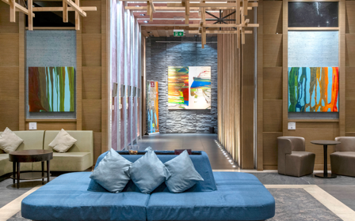 | 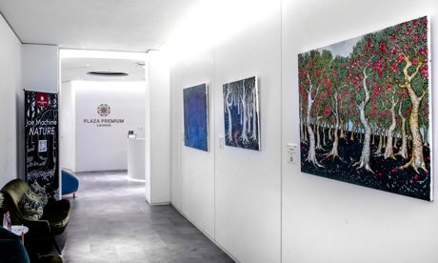
Marcia Scott Flow, Plaza Premium Lounge Heathrow Terminal 2 (installation view)  Immerse into the flow of colours with Troubadour, Camouflage and Canter at Plaza Premium Lounge. | Joe Machine Nature, Plaza Premium Lounge Gatwick North Terminal (installation view)  Painted British landscapes of Wealden Orchard with Magpies, Path Through the Beech Woods and Ghostwood with Blue Flowers welcome you to the Plaza Premium Lounge reception.

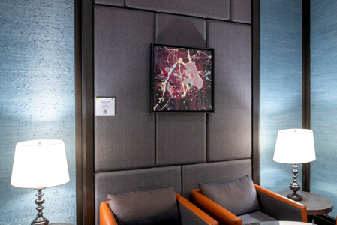 | 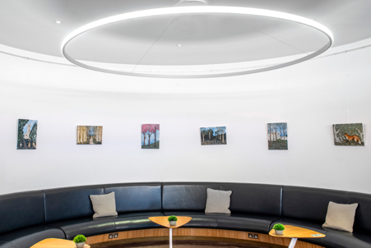
Marcia Scott Flow, Plaza Premium Lounge Heathrow Terminal 2 (installation view)  Conundrum exhibited within the interior VIP area. | Joe Machine Nature, Plaza Premium Lounge Gatwick North Terminal (installation view)  A group of exhibited paintings, including the Church with visiting Jackdaws, Meadow Walk and Prowling Fox.

For sales enquiries and to receive information about upcoming events, please contact
Amie Conway, Art Advisor & Curator  T: +44 (0)7581 111 217  E: hello@spotlight-art.com  Alex Cousens, Art Advisor & Curator  T: +44 (0)7903 295 036  E: hello@spotlight-art.com | 

Plaza Premium Group Media Contacts:
Whitney Fung, PR & Corporate Communication Executive, Plaza Premium Group
E: whitney.fung@plaza-network.com

Louise Burrows, Marketing Manager UK & Europe, Plaza Premium Group
T: +44 (0) 7445 680 909 E: louise.burrows@plaza-network.com

Download high resolution photo at: https://bit.ly/4aEDoNA

Plaza Premium Lounge Heathrow
Level 4, Terminal 2 Departures, London Heathrow Airport
Plaza Premium Lounge Gatwick
North Terminal Departures (near gates 45-55 and 101-103), London Gatwick Airport

About Plaza Premium Group
Plaza Premium Group, headquartered in Hong Kong and established in 1998, is a pioneering global airport hospitality services provider. With a mission to Make Travel Better, the group introduced the world's first independent airport lounge concept. Today, PPG operates the largest network of international airport lounges worldwide and offers a 360-degree airport experience with 13 brands under its portfolio, spanning over 250 locations across more than 80 airports worldwide and over 30 countries. From airport lounge brands - Plaza Premium Lounge & Plaza Premium First, to terminal hotels - Aerotel & Refreshhh by Aerotel, to meet and greet services - ALLWAYS, a range of airport dining concepts, global reward and membership program - Smart Traveller, and travel experience ECOsystem - oneTECO, the group is at the forefront of transforming airport experience for the better through innovative and human-led solutions.
PPG’s commitment extends beyond its own brands, as it also provides lounge management and hospitality solutions to leading airlines, alliances, and corporates worldwide. Partnerships include renowned names such as American Express, Capital One, Cathay Pacific Airways, SkyTeam, Star Alliance, Visa, and many more.
Plaza Premium Group has over 70 accolades demonstrating its exceptional achievements and commitment to service excellence. Notably, the group has received the prestigious "World's Best Independent Airport Lounge" award at the World Airline Awards by Skytrax for seven consecutive years from 2016 to 2023. TTG Asia also recognized the group as the "Best Airport Lounge Operator". In 2020, it achieved the "ISO 9001:2015" certification for its Hong Kong Headquarters. Furthermore, the group's Founder and CEO, Mr. Song Hoi-see, was awarded the “Ernst & Young Entrepreneur of the Year” and “Master Entrepreneur of the Year Malaysia” in 2018.
With a team of over 3,500 dedicated talents, PPG serves more than 20 million global passengers annually. Through a continuous pursuit of innovation and excellence, the group is experiencing exponential growth globally.
To learn more: https://www.plazapremiumgroup.com/
Connect with us: FB, IG, @plazapremiumlounge and WeChat @PlazaPremiumGroup

