***Plaza Premium Group Expands Flight Club Dining Brand at Kuala Lumpur International Airport (KLIA) Terminal 1***

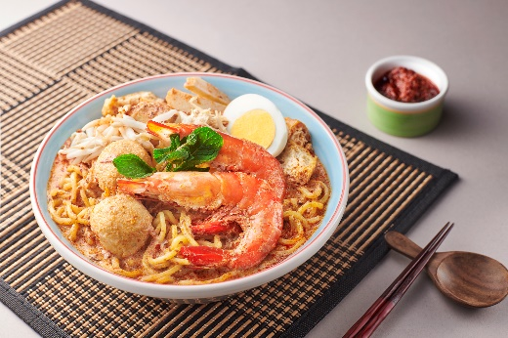 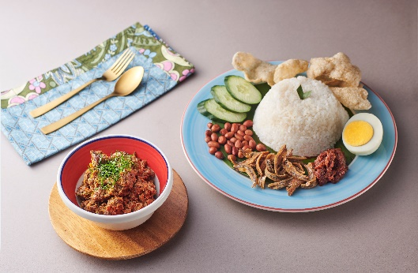

*Flight Club Unveils 24-hour Innovative Restaurant Concept with Unique Zoning*

*at KLIA Terminal 1*

[Kuala Lumpur, 2 May 2024] – Plaza Premium Group, the world's leading airport hospitality service provider is launching the Flight Club restaurant at Kuala Lumpur International Airport (KLIA) Terminal 1, the third and largest outlet in the Flight Club brand at KLIA, which already hosts Flight Club Signature and Flight Club Grab and Go.

Open 24-hours for the convenience of travellers transiting through the Malaysian capital city, the restaurant is a dining alternative that caters to different customer dining needs, ranging from quick bites, and leisurely meals to private spaces for business meetings.

As the second addition of Flight Club in Malaysia after the recent launch of Flight Club Kota Kinabalu International Airport (BKI), this latest airport dining outlet continues the concept of elevating the airport dining experience by offering freshly cooked, locally sourced international flavours and local delicacies.

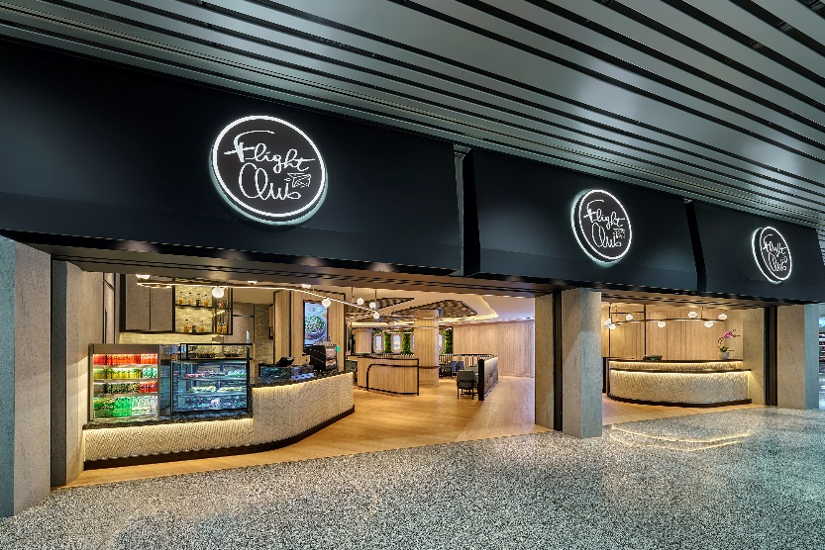 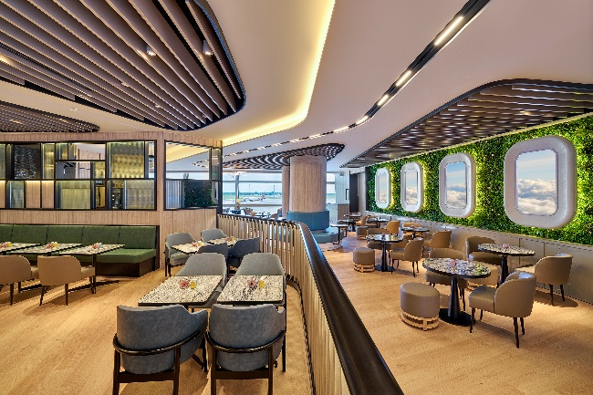

Among the highlights of the menu are signature dishes such as Nasi Lemak with Beef Rendang and Curry Laksa with Prawns. These local favourites burst with rich flavour to offer travellers a taste of authentic Malaysian cuisine authentically prepared with locally sourced ingredients.

As part of supporting local Food & Beverage businesses to foster a vibrant and sustainable community, Flight Club has also teamed up with local coffee beans supplier – espressolab on its coffee offerings to fellow passengers in the airport. By using the premium coffee beans with professional barista training provided by espressolab, the team aims to create a unique and memorable coffee moment with hand-crafted drinks.

Opening Offer:

To celebrate the outlet’s opening, Flight Club is pleased to extend an exclusive offer to fellow guests. For a limited time only, travellers who registered as Smart Traveller member and dine at the outlet are entitled to **30% off** from total bill.

*Terms and conditions apply.*

Open 24 hours, this new opening strengthens PPG's presence at KLIA, as it joins Plaza Premium First, Plaza Premium Lounge, and PPG’s other airport dining brands, including Flight Club Signature, The Summerhouse and Flight Club Grab'n'Go.

To download high resolution photos here: <https://mega.nz/folder/TiJjSBpa#Nk39FcuUkZ_xt5tLmLqJ0A>

To explore the menu and more, please visit: <https://www.airport-dining.com/flight-club>

-END-

Media Contact:

Cheng Siew Yee [email: siewyee.cheng@plaza-network.com ]

Regional Head of Marketing Communications (Southeast Asia)

**About Airport Dining by Plaza Premium Group**

Led by a team of global culinary experts, Airport Dining comprises a portfolio of dining labels to offer a selection of top-quality cuisines to complement the airport facilities in the world. Its portfolio presents herbs and seeds inspired Root98 (Hong Kong; Dammam & Jeddah - Saudi Arabia; Clark - The Philippines; Vancouver & Winnipeg - Canada); healthy options Flight Club (Kuala Lumpur - Malaysia; Sihanoukville - Cambodia; Bali - Indonesia; Muscat - Oman); Korean delights Lee Fa Yuen Express (Hong Hong); Japanese and Korean-inspired cuisine TGM (Clark – The Philippines; Helsinki- Finland; Singapore); and Casual Chinese dining Terrace Chinese Kitchen (Singapore); Sky Bar & Restaurant Intervals (Hong Kong) and summer-inspired dining The Summerhouse (Kuala Lumpur – Malaysia).

To learn more: [www.airport-dining.com](http://www.airport-dining.com)

**About Plaza Premium Group**

Plaza Premium Group, headquartered in Hong Kong and established in 1998, is a pioneering global airport hospitality services provider. With a mission to Make Travel Better, the group introduced the world's first independent airport lounge concept. Today, PPG operates the largest network of international airport lounges worldwide and offers a 360-degree airport experience with 13 brands under its portfolio, spanning over 250 locations across more than 80 airports worldwide. From airport lounge brands - Plaza Premium Lounge & Plaza Premium First, to terminal hotels - Aerotel & Refreshhh by Aerotel, to concierge services - ALLWAYS, a range of airport dining concepts, global reward and membership program - Smart Traveller, and travel experience ECOsystem - oneTECO, the group is at the forefront of transforming airport experience for the better through innovative and human-led solutions.

PPG’s commitment extends beyond its own brands, as it also provides lounge management and hospitality solutions to leading airlines, alliances, and corporates worldwide. Partnerships include renowned names such as American Express, Capital One, Cathay Pacific Airways, SkyTeam, Star Alliance, Visa, and many more.

Plaza Premium Group has over 70 accolades demonstrating its exceptional achievements and commitment to service excellence. Notably, the group has received the prestigious "World's Best Independent Airport Lounge" award at the World Airline Awards by Skytrax for seven consecutive years from 2016 to 2023. TTG Asia also recognized the group as the "Best Airport Lounge Operator". In 2020, it achieved the "ISO 9001:2015" certification for its Hong Kong Headquarters. Furthermore, the group's Founder and CEO, Mr. Song Hoi-see, was awarded the “Ernst & Young Entrepreneur of the Year” and “Master Entrepreneur of the Year Malaysia” in 2018.

With a team of over 3,500 dedicated talents, PPG serves more than 20 million global passengers annually. Through a continuous pursuit of innovation and excellence, the group is experiencing exponential growth globally

To learn more: https://www.plazapremiumgroup.com/

Connect with us: FB, IG, @plazapremiumlounge and WeChat @PlazaPremiumGroup